**Homework 1 Report**

D11315807

Ardiawan Bagus Harisa

Department of CSIE

In this homework project, I do not read the sample code from TA on Moodle, therefore I apologize that my implementation may be varied from the sample.

1. **Draw a Crescent Moon**

First, I modify the sample code from the first meeting and create a drawCircle() functions. I set the color of the vertex to be white (RGB 1,1,1). Then using a loop, I calculate the x, y coordinates on the perimeter of the circle, by converting the polar coordinate into cartesian. Through that loop, we draw the vertex from x, y = 0,0 to x, y calculated from the loop, relative to the center of circle.

This is the drawCircle() function:

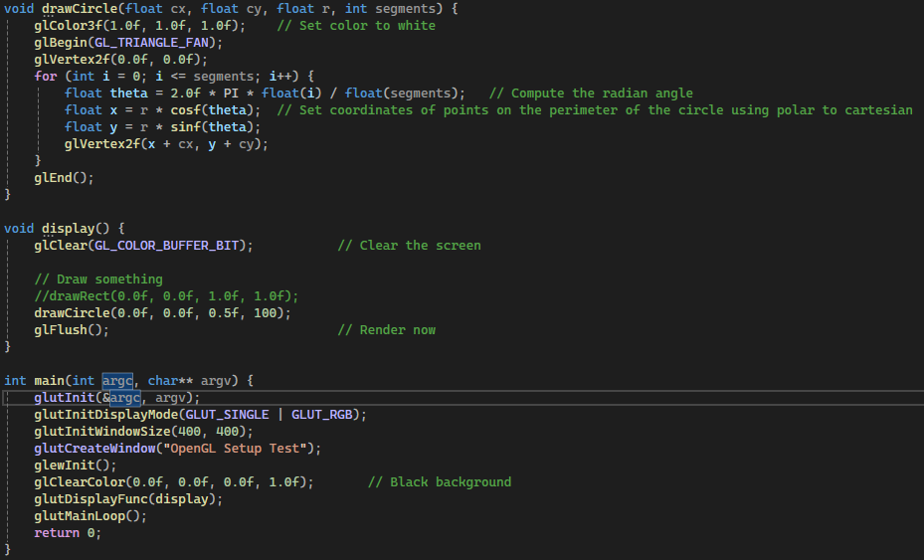

As you may see, I just modify the setup sample code, and modified the display() function. There, I just call the drawCircle() inside the display() where it will also be called in main(). Then, this is the resulting circle:

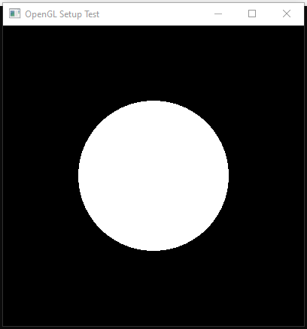

So, the next step is just to draw another circle with black color above the first one. But then, I just realized that the color variable in original OpenGL is not provided. So, I just create the Color struct, therefore I can call drawCircle() in a more convenient way. I also changed the moon’s color. This is the final result:

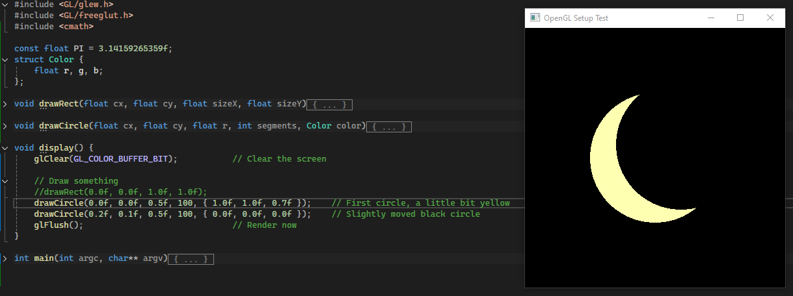

1. **Draw Smiley Face**

For the second project, again, I just modify the first project because I want to work in the same project. Instead, I just create multiple windows in a project. First, I create an integer variable to hold the window’s ID. Then, create the function to initialize the window, where I can later pass the parameters like size, position, and what drawing function I need to call. Finally, I just call the window function to the main function. With this, I don’t need to create two projects.

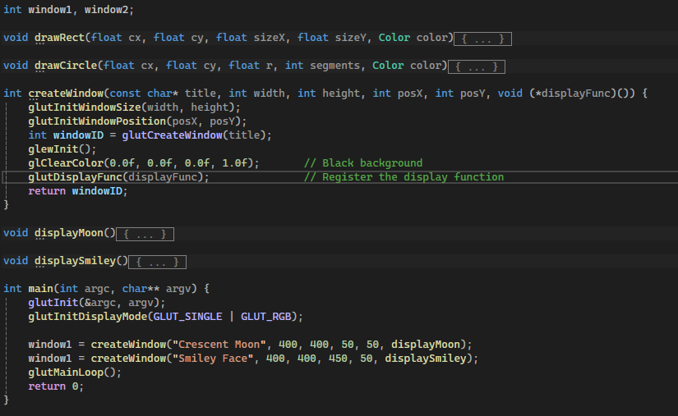

With this displaySmiley() function, I aim to draw Anpanman.

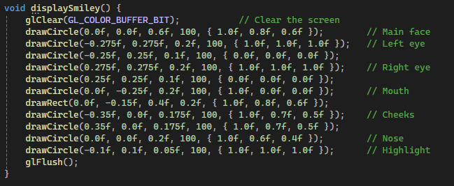

The results and the reference:

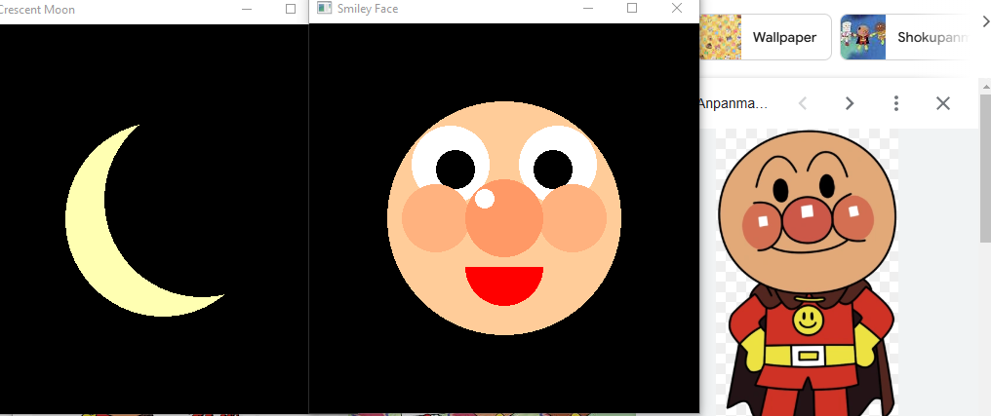

Notes:

* I push my code here: <https://github.com/ardiawanbagusharisa/cgopengl>
* I just realized that I write unnecessary code, after I finish my code, and then re-evaluate using Sohan’s.

